GFTB KIAMBU PROJECT SUMMARY
- The Kiambu Global Fund Kiambu TB ACF Project is a donor funded project by Global Fund through AMREF Health in Africa Kenya.
- The project implementation area is Kiambu County which has a population of approximately 2.5 million people.
- The project is implemented in all the 12 Sub Counties i.e Gatundu North & South, Githunguri, Juja, Kabete, Kiambaa, Kiambu, Kikuyu, Lari, Limuru, Ruiru & Thika.
- The current project runs for a period of three years from July 2021 to June 2024.
- The goal of the project is to ensure provision of quality care and prevention services for all people in Kenya with TB, Leprosy and Lung diseases.
- The key target areas include;
- TB Care and prevention
- TB/HIV
- MDR TB
- RSSH
- COVID 19 Activities
- ODSS
- Community ACF is the back bone of the project whereby key interventions that aim at improving TB case find and retention are carried out. These are;
- Contact tracing for bacteriologically confirmed TB patients
- Reverse contact tracing for children under five years with TB
- Treatment interrupters tracing
- Some of the important milestones that have been achieved for key interventions above to date are as follows;
- 4350 Households of bacteriologically confirmed TB patients have been visited for contacts screening
- Approximately 10,850 contacts of bacteriologically confirmed patients have been screened and offered health education on TB prevention and treatment
- More than 150 contacts have been identified to be having TB and have been put on treatment
- Over 500 treatment interrupters have been traced, processed and at least 70% returned back to treatment
- 16 outreaches targeting drug dens, work places and informal settlements have been supported
- 6750 people were screened for TB through outreaches and just above 150 cases of TB identified
- 106 support TB patients’ psychosocial meetings (PSSGs) held improve patient treatment compliance and knowledge

Photographs

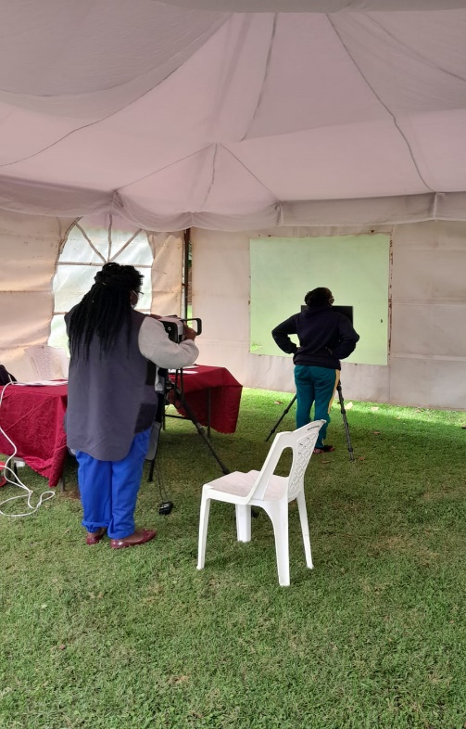
A patient being taken X-ray using digital X-ray machine at Limuru Sub County, Kiambu County during a recent outreach

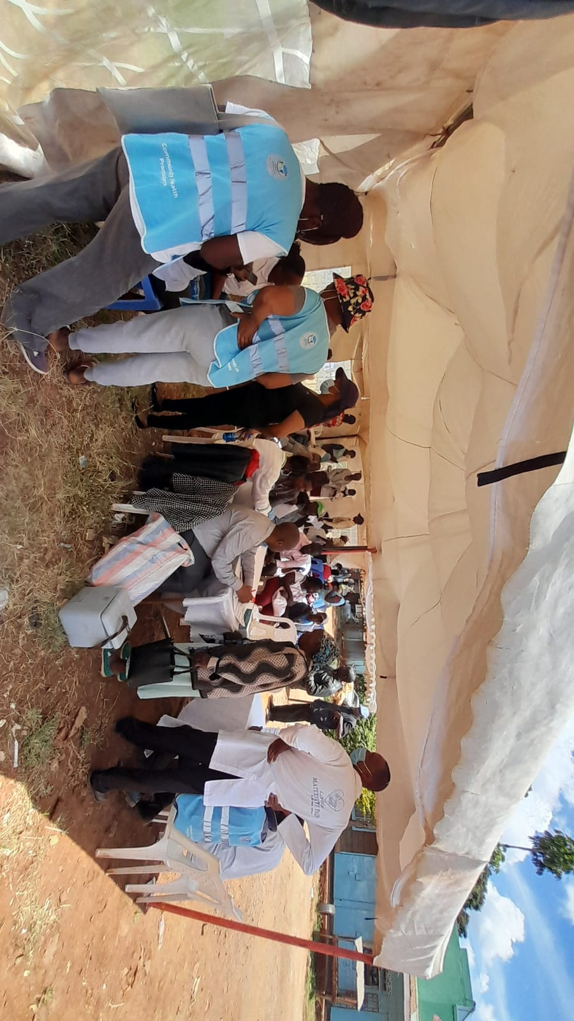
People being screened at an Outreach held at Githunguri Sub County, Kiambu County in March 2024 to commemorate World TB day.

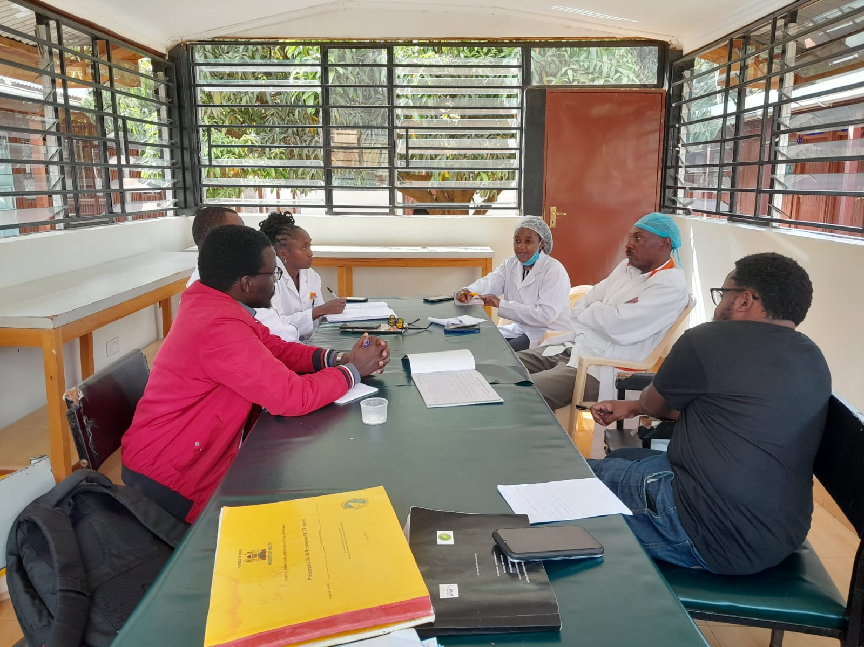
A discussion at Thika Level 5 Hospital with HCWs on Program Quality and Efficiency (PQE) for TB and QI improvement at the facility
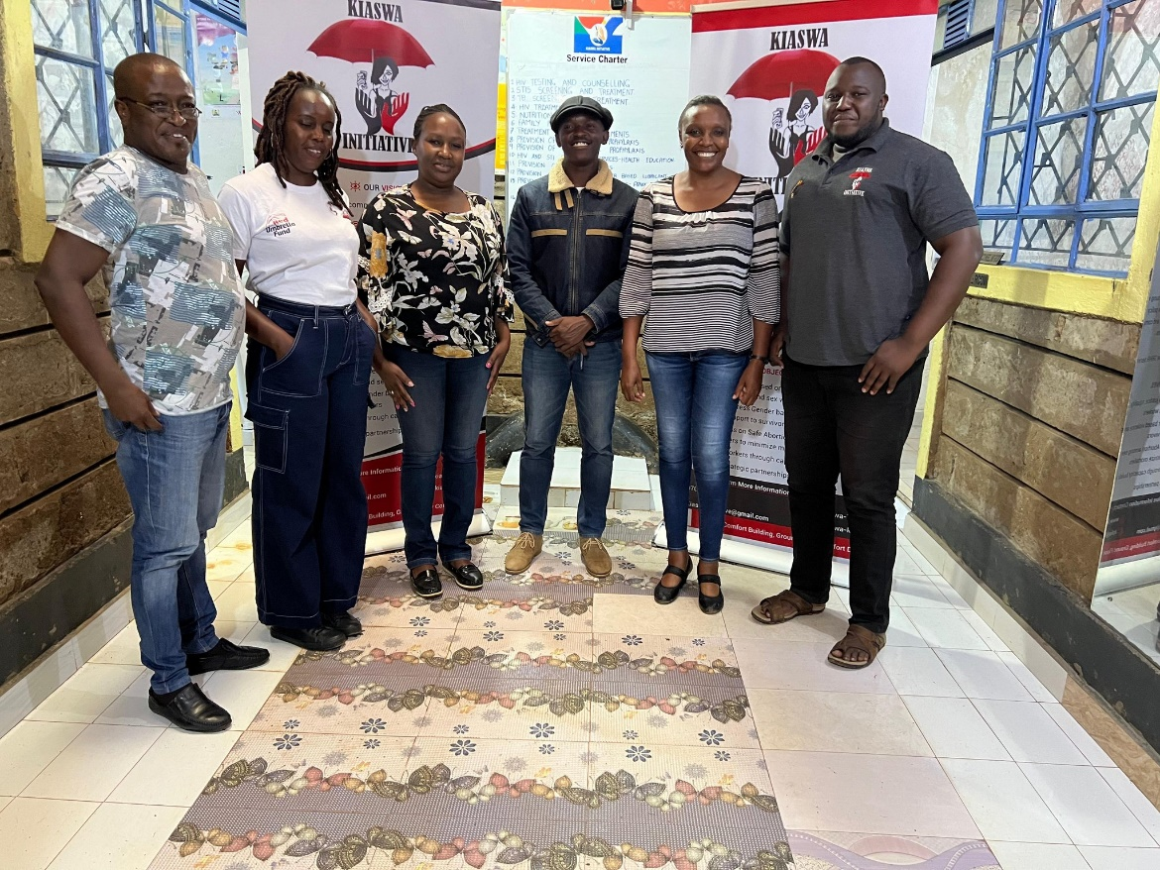
Photo session after ODSS Training at KIASWA Initiative in April 2024

